Approving a Requisition

Objective
This document provides instruction for approving released requisitions. It is intended for personnel responsible for approving requisitions.

Overview
The Workflow Detail Web part, in conjunction with the Workflow business rules, establishes an electronic approval process for requisitions. When a requisition is released in Munis, the requisition is submitted to an approval process. The requisition must be approved by all necessary approvers in order for it to be converted into a purchase order or contract. This document describes the approval process using the Tyler Dashboard Workflow Detail Web part.

Prerequisites
Before you can successfully complete this process, you must ensure that roles granting the necessary permissions have been assigned to your user account. If the roles have not been established, contact the system administrator to have them updated or added into the Munis system.

Confirm the following:

Requisitions have been completed and released.
Workflow business rules are established.
You are included in the Workflow User Attributes program as an approver.
You have access to the My Workflow Detail Web part from the Tyler Dashboard.

Procedure
To process a single requisition:
- Open the Tyler Dashboard.
On the My Workflow Detail Web part, the Approvals image indicates if approvals are required.
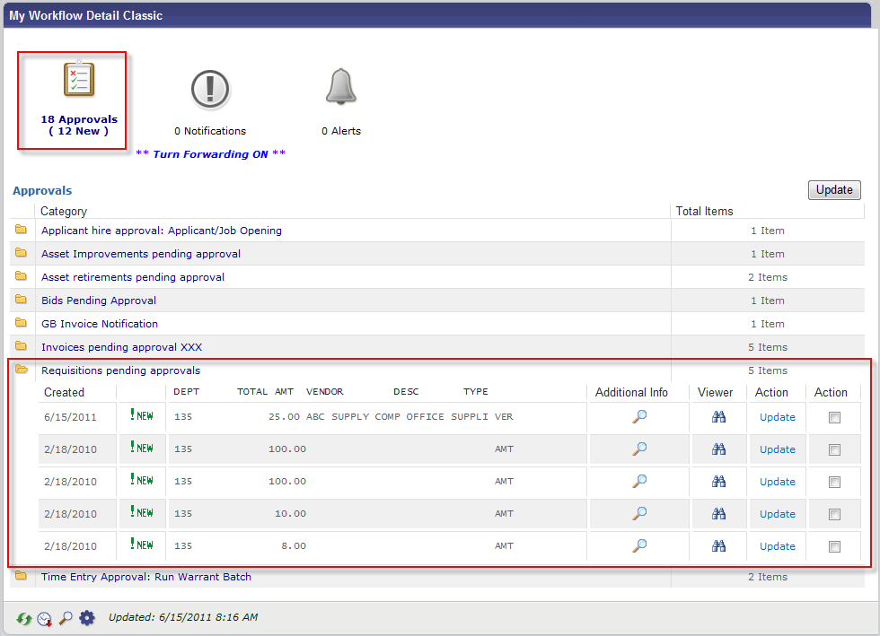
- In the Requisitions Pending Approvals group, click the Viewer button for the requisition to approve.
The program opens the Requisition Entry program, with the selected requisition as the active record.
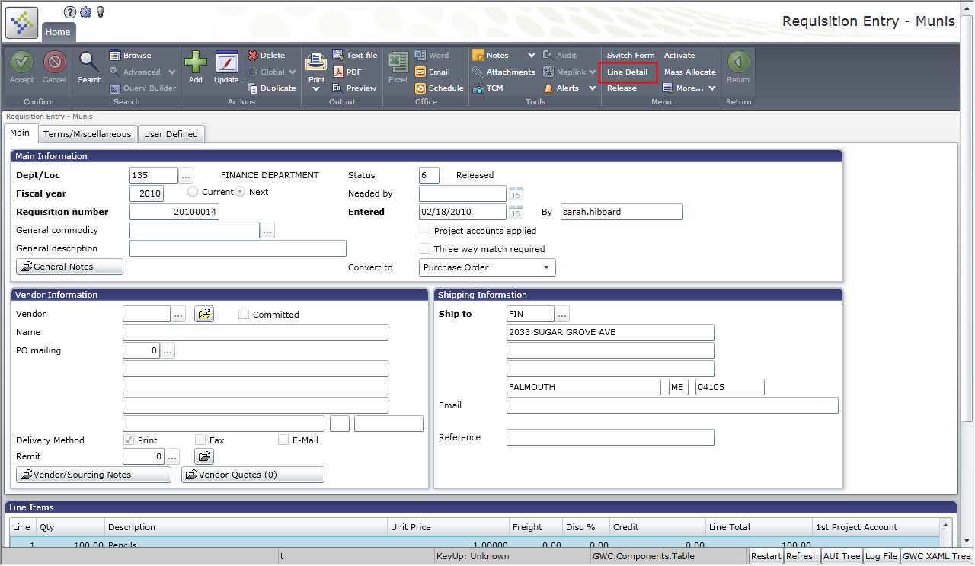
- Review the requisition, paying careful attention to details included in the General Notes, Vendor Sourcing Notes, and Vendor Quotes options. (If vendor quotes are associated with the requisition, the Vendor Quotes button displays the number of the quotes.) To view the line detail for each line item, click the Line Detail option.
- When you have completed the requisition review, close the Requisition Entry program and return to the Tyler Dashboard.
- Click the Information button to view additional workflow details for the item.
The program displays the Work Flow – Additional Information screen.
- Click Update to complete workflow action for the item.
The program displays the WorkFlow Update screen.
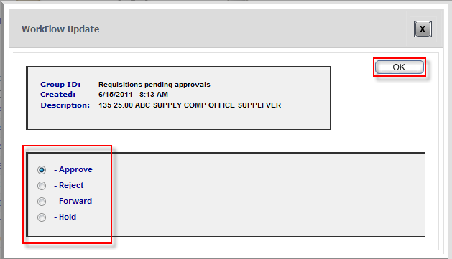
- Select the appropriate action, and then click OK.
Option | Description
Approve | Approve the requisition. Select Approve and click OK.  This approves the requisition as recommended and forwards to the next approver. When all approvers have approved, Purchasing personnel are notified.
Reject | Change the status of the requisition to Rejected. Munis requires that you add a comment for your action. When you click OK to save your comment and reject the requisition, the program notifies Purchasing personnel of the rejection and the reason.
Forward | Forward the requisition to another Workflow approver.  The program prompts you to provide a comment for your action. To complete the forward, select the Workflow approver from the list and then provide a comment in Comment box. When you click OK to save the forwarding information, the program forwards the requisition to the new approver.
Hold | Allows you to keep the requisition in your approval queue. A comment is required for this action. To place a requisition on hold, enter a comment and then click OK to hold the approval process.  The held bid will remain in the Workflow Requisition Approval folder until action is taken.
The program displays an approval confirmation.

To approve multiple requisitions using the Tyler Dashboard:
- Click the Viewer buttonfor each item to view the requisition details in the Requisition Entry program.
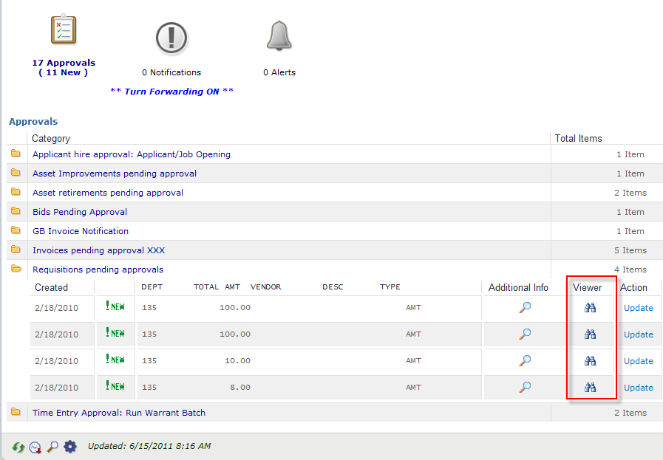
- Once all the requisition records are reviewed, select the Action check box for each item for which to complete a workflow action.
- Click the Update button.
The program displays the Workflow Update grid.
- Select the applicable action for each item, and then click OK.
If you select Reject, Forward, or Hold for any of the items, the program requires that you enter a reason for the action.
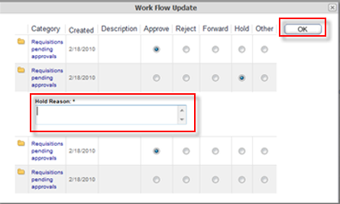
- Enter the reason, and then click OK again.
The status of rejected requisitions is changed from 6–Released to 1–Rejected. The status of approved requisitions remains at 6–Released until the approval of the final step in the approval process. At that time, the status changes to 8–Approved. Requisitions with a status of 8–Approved are eligible for conversion to purchase orders. Rejected requisitions may be corrected by the originators, and resubmitted to the approval process.

Results
The requisition has completed the approval process.

Status Change
The status of rejected requisitions is changed from 6–Released to 1–Rejected.
The status of approved requisitions remain at 6–Released until the approval of the final step in the approval process. At that time, the status changes to 8–Approved.

GL Impact
There is no impact on the general ledger accounts at this time.

What’s Next?
Requisitions with a status of 8–Approved are eligible for conversion to purchase orders.
Rejected requisitions may be corrected by the originators and resubmitted to the approval process.

